Visitor Services for 2026 CTEF
China International Chemical Technology and Equipment Fair
- Service Content

To ensure a smooth experience for visitors to the 2026 CTEF China International Chemical Technology and Equipment Fair (hereinafter referred to as "CTEF") , the organizing committee provides a one-stop service , integrating local accommodation in Shanghai , exhibition visit services, visits to well-known chemical equipment companies in Shanghai, and cultural and tourism services in Shanghai . This helps visitors efficiently connect with industry resources and allows for flexible customization of itineraries based on their needs.
- Service period
June 9-11, 2026, Shanghai New International Expo Centre. Service period can be flexibly customized, usually 3-5 days (including 1-2 days for exhibition visits, 1 day for company visits, and 1 day for cultural and tourism support), and the duration can be adjusted according to the needs of the visitors.
- Itinerary Planning
VIP Visitor Group Activity Schedule

Date | Time | Event Details
8 June 2026 | All day | Arrive to Shanghai
8 June 2026 | All day | Shanghai Airport to Hotel Check-in
9 June 2026 | 9:00 - 9:30​​ | Vehicle Transportation to Exhibition Hall
9 June 2026 | 9 :30-12:00 | Free Visit and Exchange
9 June 2026 | 12:00-13:30 | Lunch
9 June 2026 | 13:30-16:50 | Free Visit and Exchange
9 June 2026 | 17:10 | Return to Hotel
10 June 2026 | 9 : 00-9 : 30​ | Vehicle Transportation to Exhibition Hall
10 June 2026 | 9:30-12:00 | Free Visit and Exchange
10 June 2026 | 12:00-13:30 | Lunch
10 June 2026 | 14:00-16:50 | Free Visit and Exchange
10 June 2026 | 17:10 | Return to Hotel
11 June 2026 | 8:30-10:00 | Go to Factory
11 June 2026 | 10:00-12:00 | Factory Tour and Seminar
11 June 2026 | 12 : 00-1 3:30​ | Lunch
11 June 2026 | 1 3 :30-16:30 | Factory Tour and Seminar
11 June 2026 | 17:00 | Dinner & Return to Hotel
12 June 2026 | All day | Travel
13 June 2026 | End
- Service Registration Form
Company Name
Name |  | gender
Passport number |  | nation
Company Name |  | Job
Email |  | Phone number
Service Option Request Form
Service Content | Fee Standard | Select your preferred option  (√) | Remark
Accommodation services | Five-star : 800 RMB/room/night；  Four-star : 600 RMB/room/night；  Three-star : 400 RMB /room/night； |  | Please fill in your request  Room type：  Check-in time:  Check-out time:  Number of nights:
Airport pick-up / drop-off vehicle services | Arrangements will be made based on the distance to the hotel once it is confirmed. |  | Number of passengers:  Outbound flight number:  Arrival time:  Arrival airport:  Return time:  Return airport:
Exhibition hall - hotel round-trip service | Vehicles will be arranged according to the actual number of people. |  | Number of people:
Factory visit services  (Attachment 5 ) | RMB 10,000 per person |  | Number of people:  Intended equipment companies:
Unique cultural and tourism services around Shanghai  (Appendix 6) | Customized routes based on needs |  | Route 1  Route 2  Route 3
Other services
( Translation, tour guide, and other services )
Total Cost
Organizer's bank account information | Account: Guangzhou Zhenwei International Exhibition Co., Ltd  Bank Name: BANK OF CHINA GUANGZHOU POLY INTERNATIONAL PLAZA SUB-BRANCH  Swift Code: BKCHCNBJ400  Accnount No: 6574 5830 7344
Terms of Service:
1. Upon confirmation of the desired services, please pay the full reservation fee within three days of returning the registration form, according to the bank account information provided.
2. Services can be freely combined and selected. For business factory visits, please inform the organizer of your industry requirements in advance.
3. For invoices , please contact the organizing committee. CTEF Organizing Committee Contact Information:
Contact:
chen
chenweiyi@zhenweiexpo.com
+86 181 2799 1242

VII. Attached Documents
Appendix 1: Exhibition Hall Location Map
Appendix 2: Traffic Guide
Appendix 3: Exhibition Schedule & Visitor Handbook & Conference Agenda
Appendix 4: List of Hotels
Appendix 5: Site Visit Arrangement
Appendix Six: Other Popular Attractions

Appendix 1: Exhibition Hall Location Map
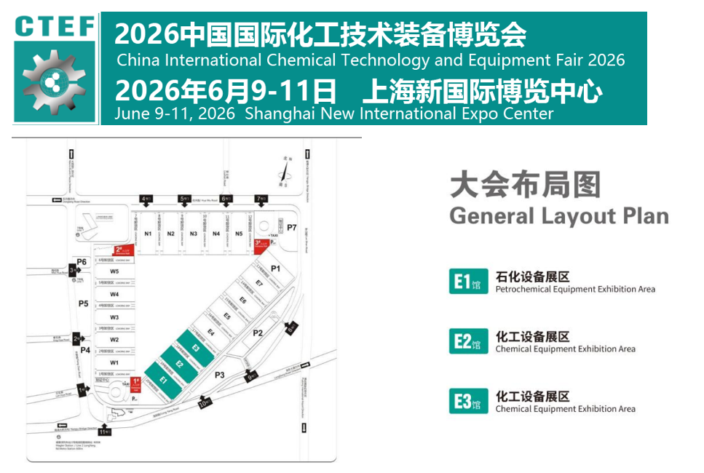

Appendix 2: Traffic Guide
Location: Shanghai New International Expo Center (Halls E1-E 3 )
Specific address: No. 2345, Longyang Road, Pudong New Area, Shanghai
- Transportation Guide
- Airplane
- Pudong International Airport: Maglev → Longyang Road Station → Transfer to Line 7 to Huamu Road Station
- Pudong International Airport: Metro Line 2 → Longyang Road Station → Transfer to Line 7 to Huamu Road Station
- Hongqiao International Airport: Metro Line 2 → Longyang Road Station → Transfer to Line 7 to Huamu Road Station

- Maglev Train
The Maglev Train runs between Pudong International Airport and Longyang Road Station on Metro Line 2 in just 8 minutes. You can then transfer to Metro Line 7 to Huamu Road Station.
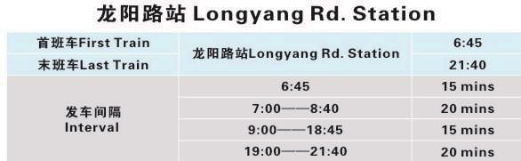
- Rail Transit
Metro Line 2: Zhongshan Park Station to Longyang Road Station (600 meters on foot)
Metro Line 7: Shanghai University to Huamu Road (200 meters on foot)

Appendix 3:
China International Chemical Technology and Equipment​ Fair Event Overview
Time；June 9-11，2026
- Tuesday, June 9, 2026, 09:00-16:30
- Wednesday, June 10, 2026, 09:00-16:30
- Thursday, June 11, 2026, 09:00-13:00
Exhibition Venue: Shanghai New International Expo Center，E1-E3
Detailed Address: No. 2345, Longyang Road, Pudong, Shanghai
 | 08:30-17:00 | China International Chemical Technology and Equipment Fair | Shanghai New International Expo Center
Tuesday June 9
Concurrent Events
 | 10:00-12:00 | China International Chemical Equipment Innovation  and Development Conference | Shanghai International Expo Center E3 Hall  Conference and Forum Area
 | 11:00-12:00 | CTEF Enterprise Product Debut and New Product Launch Event | Shanghai International Expo
 | 12:00-12:30 | The 3rd China Chemical Technology Equipment  "Golden Gear Award" Ceremony | Shanghai International Expo Center E3 Hall  Conference and Forum Area
 | 13:30-15:35 | Special Forum on Application and Innovation of Heat Pump Distillation and Energy saving Optimization Technology | Shanghai International Expo Center E3 Hall  Conference and Forum Area
 | 15:35-17:00 | Special Forum on Application and Innovation of Evaporation  and Crystallization Technology | Shanghai International Expo Center E3 Hall  Conference and Forum Area
 | 18:30-20:00 | CTEF Global Chemical Technology and Equipment Business Exchange Night | Shanghai International Expo Center E3 Hall  Conference and Forum Area
 | Procurement docking
 | 09:40-10:00 | Opening Ceremony of International Procurement Matchmaking Conference  - Procurement Needs from Multiple Countries including Asia Europe, Central Asia, Middle East, Southeast Asia, etc | Shanghai International Expo Center E3 Hall  Conference and Forum Area
 | 10:00-12:00 | International Procurement Matchmaking Conference  - Special Session for Asian and European Countries | Procurement docking area of Hall E3 of  Shanghai International Expo Center
 | 13:30-16:30 | International Procurement Matchmaking Conference | Procurement docking area of Hall E3 of  Shanghai International Expo Center
Wednesday June 10
Concurrent Events
 | 10:00-12:00 | Special Forum on the Application and Innovation of High Efficiency Heat Transfer Technology in Chemical Heat Exchangers | Shanghai International Expo Center E3 Hall  Conference and Forum Area
 | 10:00-12:00 | Micro Chemical and Continuous Flow Technology Application  and Innovation Forum Special Forum | Shanghai International Expo Center E3 Hall  Conference and Forum Area
 | 13:30-15:35 | Special Forum on Application and Innovation of Chemical Material Processing and Transportation Technology | Shanghai International Expo Center E3 Hall  Conference and Forum Area
 | 15:35-17:00 | Seminar on Chemical Environmental Protection  Waste Treatment and Resource Utilization Technology | Shanghai International Expo Center E3 Hall  Conference and Forum Area
 | Procurement docking
 | 10:00-12:00 | International Procurement Matchmaking Conference  - Central Asian Countries Special Session | Procurement docking area of Hall E3 of  Shanghai International Expo Center
 | 13:30-16:30 | International Procurement Matchmaking Conference  - Southeast Asian Countries Special Session | Procurement docking area of Hall E3 of  Shanghai International Expo Center
Thursday June 11
Concurrent Events
 | 10:30-12:00 | China Smart Chemical and Digital Transformation Forum | Shanghai International Expo Center E3 Hall  Conference and Forum Area

Appendix 5: Site Visit Arrangement
1. Pre-visit coordination: The organizing committee communicates with the companies to visit in advance to confirm the visit time, process, and reception personnel, informs the companies of the composition and needs of the audience, and assists the companies in preparing visit materials (company introduction, product manual, technical specifications, etc.).
2. Round-trip transportation: A private bus will be arranged to transport visitors between the hotel and the companies they wish to visit;
3. On-site inspection:
(1) Company introduction: The person in charge or technical director of the company will explain the company's development history, core products, technological advantages, production scale and industry application cases;
(2) Workshop visit: Accompanied by company staff, visit the production workshop and R&D center to inspect the equipment production process, assembly process and quality inspection process (comply with the company's safety regulations and inform visitors of the precautions for visiting in advance).
(3) Exchange and negotiation: Organize exchanges between the audience and the enterprise's technical team, and arrange seminars ;

Appendix Six: Cultural and Tourism Routes Around Shanghai
Route 1: Oriental Pearl Tower + Huangpu River Cruise + City God Temple Tourist Area + Bund Day Trip
Route 2: Zhujiajiao Ancient Town Day Trip
Route 3: Shanghai-Wuzhen Day Trip
*We can customize your itinerary.

